In the past two weeks, my focus was on sales prediction and recall service enrichment.

Previous, I have developed an algorithm for trending detection. The logic is rather simple and it is based on an assumption that, a trending item / keyword now will keep being trending for next few days.Therefore, in order to find trends in next few days and prepare items accordingly (as we are e-commerce platform), we will capture yesterday’s trending items / keywords, and use them directly as trends in next few days.

In our experiment, our trending detection algorithm easily outperformed previous naive method, i.e. assume top sale items as trending items, by all aspects, such as order count.

However, it is obvious that the assumption of the whole algorithm is not always true. In trend detection, by twitter’s definition, there are three basic types of anomalies as following:

**Ramp-up**: starting from a well-established equilibrium state, characterized by insignificance, constancy, or periodicity, demonstrating a persistent and enduring growth pattern.

**Mean shift**: the time series suddenly shifts from a familiar and stable average value to a substantially different one, and this new value persists for a considerably longer duration than the expected.

**Pulse**: starting from a stable and comprehensible state, the time series experiences a substantial rise in value, followed by a return to its previous typical values.

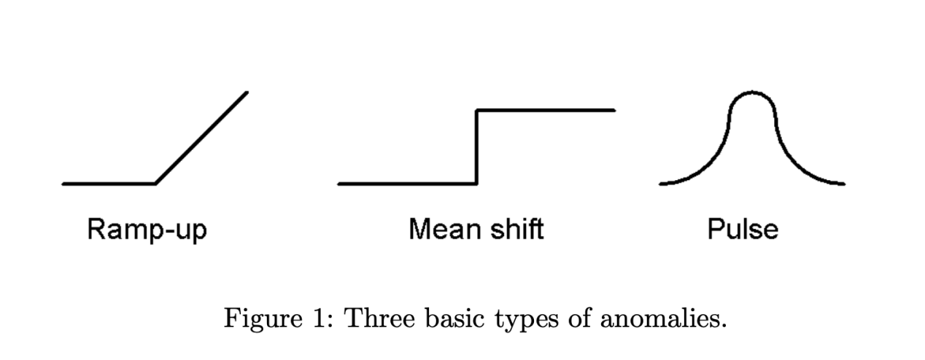

In our experiment, most of the trending items / keywords we found below to the “pulse” type, which shows that our previous assumption may not be solid. Therefore, we will need a new algorithm that not only can capture trends, but also capable of predicting trends.

To do so, we referred to an presentation from Taobao, one of the leading e-commerce platform in the world.

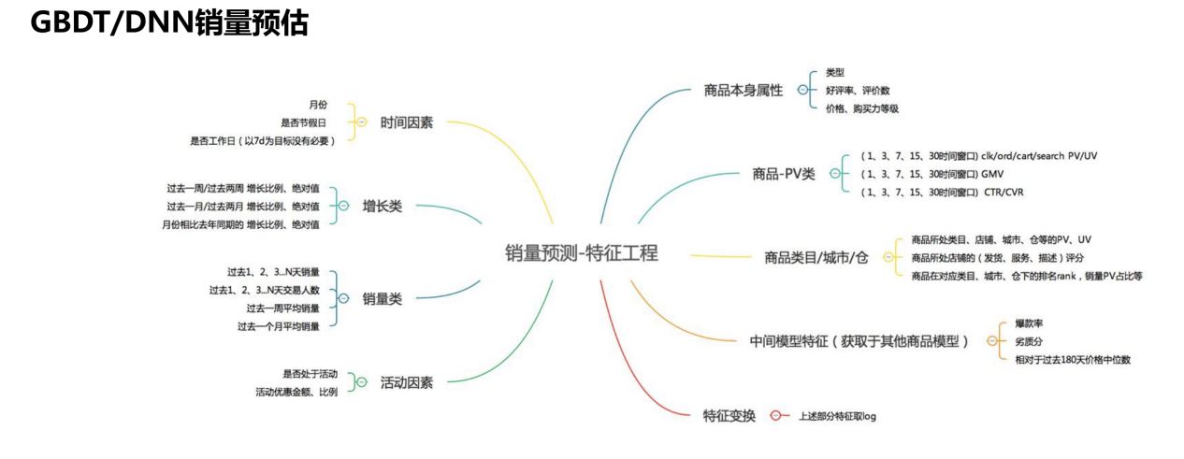

They have shared their feature engineering work for sales prediction. Although it is not entirely the same as trend prediction, we however can extend from here to actually predict trends. In the past two weeks, I have finished feature engineering work based what we have and our goal, some the features I prepared is not entirely the same as the above picture listed. Next I will work the the model build up to test the trend detection.

The second thing I did is to enrich recall service for product collection project. In foreseeable future, some of the project will be applied on product collection. However, as product collection is a fairly new project, we have not added much functionality into it. Thus, to support future needs, we decide to enrich recall service to guarantee a proper performance when it is in use.

In this expansion, we added over 10 recall queues into our recall service, including user-item interactions queues, item-2-item queues and item-2-item-co-purchase queues. I have finished documents preparation, and in next two weeks, I will start ingest data into live environment and align with back-end side for them to support our request.